

*\*\*\* Steps do not necessarily indicate years of experience.*

Generator Base **$31,048**

Non-degreed nurses' generator base= 83% of teachers' generator base.

Minimum salary for certificated teachers **$42,456**

Maximum starting salary for new certificated teachers - Step 13.

#Training increment. Not eligible to advance except upon completion of 6 semester hours of approved work during the preceding 5 yrs.

* =Maximum step for lane

**Salaries include additional **$5,121** Teacher Compensation pay which is subject to change annually. You must be eligible to receive Teacher Compensation pay.

**ADDITIONS TO SALARY**

RN + 60 approved hrs.--$400 additional

MA+45--$1000 additional

PHD--$2,000 additional

LONGEVITY: (1) Those employees who have been at the maximum of their salary column for more than 1 year shall receive additional salary computed on the % of the generator base as follows plus the amount of the embedded step:

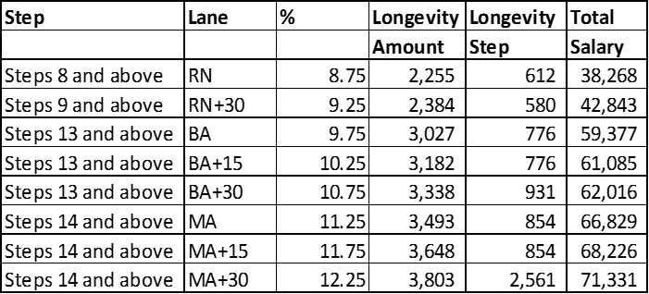

(2) In addition to the above longevity, those employees who have been at Step 20 of their salary column for more than one year (Steps 21 and above) shall receive additional salary/longevity at 2.5% of the generator base: RN=$644; and BA through MA+30=$776. This amount should be added to the “Total Salary” listed in the above table.

Recruitment Incentive=The Employer has the sole discretion to post positions on or about January 1, April 1, and July 1 identified as acute shortage areas and to provide a recruitment incentive of $3,000. Receipt of this incentive will be contingent upon provision of satisfactory service with payment equally distributed over a 3-yr period, e.g. 72 semi-monthly payments.