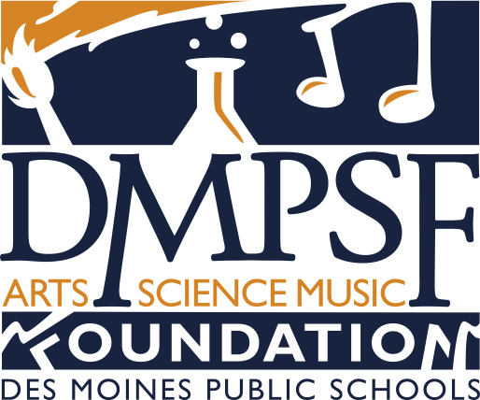
K-8 TEACHER GRANT APPLICATION 2016-2017 SCHOOL YEAR

SUBMISSION DEADLINE: MONDAY, DEC 5, 2016

Applicant’s Name Date

Position Building

School Phone: Home/Cell Phone:

$
Project Title Total Request ($1,000 max)
This project is related to the following curriculum(s):

Science Performing Arts

Visual Arts Music
Please provide the following by the last day of the semester in which the grant funds are used:
- A written summary of the project/activity; please include specific measurable data
- Photographs and/or video illustrating the project/activity to be used in DMPSF promotional/awareness materials

By signing below, you are indicating that you have read and understand assessment expectations, and that you allow release of any photos/video for DMPS Foundation use.

_______________________________________________________________________
Applicant/Date

_______________________________________________________________________
Building Principal/Supervisor/Date

- Please provide a brief summary, description and include research data (attach documentation) of the project/activity

- When do you anticipate implementing and completing the project? (Please provide dates)

- Number of students utilizing this project:
Grade level(s) of students:

- What are the specific educational objectives of the project as they relate to the Des Moines Public Schools’ science, art, and/or music curriculums?

- Why is your project needed?

- How will your project enrich/enhance learning in a new way?

- Detail your budget request. Include specific information, such as kinds of material and equipment needed, sources of supplies, and cost. Categories include materials, equipment, transportation, honoraria, refreshment, rentals, etc.

Category | Description | Supplier | Amount
Examples: Material | Six (6) Palette Boards | ABC Supply | $96.00
Consultant from  XYZ Company | 6 hours of working with students | XYZ company  Transportation & meals | 200.00  150.00

TOTAL $______________

8. List any other sources of funds for this project with the dollar amounts.

Submit applications on or before Monday, December 5, 2016, to:

Deb Pendleton
Des Moines Public Schools
2323 Grand Ave.
Des Moines, IA 50312
[or e-mail: debra.pendleton@dmschools.org]

The written summary and photographs/video, DUE BY JULY 1, 2017, may be sent to the same contact.

